
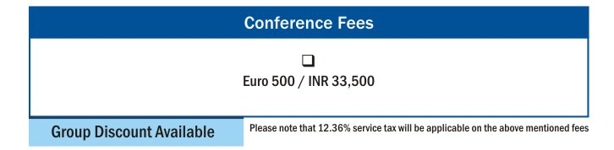

For more information
Contact: Meghana Shah
Tel: +91-22-40820162 | Email : meghana.shah@informedia-india.com

